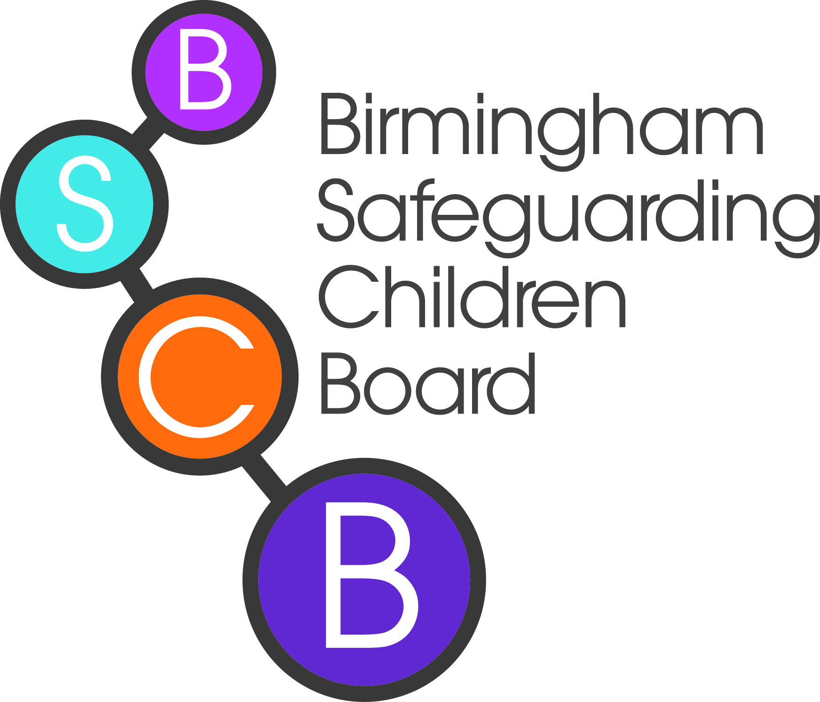
Child Sexual Exploitation Screening Tool
Child sexual exploitation is a form of abuse. It involves children and young people being forced or manipulated into sexual activity in exchange for something- money, gifts or accommodation, or less tangible goods such as affection or status. The sexual activity and exchange may be seen as consensual, but are based on an imbalance of power which severely limits victims’ options. This Tool has been developed to enable the identification of children and young people at risk of sexual exploitation.

Name of child/young person:____________________ Date of Birth__________________
Significant Risk Indicators | Current or during the past 6 months: | Prior to 6 months ago:
Periods of going missing day and/or night
Relationship of concern with a controlling adult (male or female) or young person, which might involve physical and/or emotional abuse and/or gang activity
Entering/leaving vehicles driven by unknown adults (not car theft)
Unexplained amounts of money, expensive clothes or other items
Frequenting areas known for risky activities
Groomed/abused via the Internet and mobile technology
Having unexplained contact with hotels, taxi companies or fast food outlets

Medium Risk Indicators | Please tick
Whereabouts unclear or unknown – day and/or night
Absences/exclusion from school or not engaged in school/college/ training/work
Multiple callers – Unknown adults/young people
Physical injuries without plausible explanation
Sexually transmitted infections/ Pregnancies / termination of pregnancies
Drugs Misuse
Alcohol Misuse
Self-harming/challenging behaviours/suicide attempts/ eating disorders/aggression
Use of a mobile phone which causes concern – including sexting/multiple phones/sims
Unsafe use of internet
Has been sexually assaulted
Disclosure of sexual/physical assault followed by withdrawal of allegation
Risky/inappropriate sexual behaviour
Lack of awareness/understanding of being safe
Peers involved in sexual exploitation/risky or concerning behaviours
Living independently and failing to respond to attempts by workers to keep in touch
A&E attendance because of alcohol/drug misuse
Being accompanied to appointments by an unknown person that causes concern
Association with gang members that suggests sexual exploitation is a possibility

Vulnerability Factors | Please tick
Unsuitable/inappropriate accommodation/sofa surfing
Isolated from peers/family/social networks
Sexual abuse (during childhood)
History of Local Authority Care
Involvement in criminal activities and/or at risk of gang involvement
Breakdown of family relationships
History of Child Protection involvement in relation to neglect, physical or emotional abuse
Family history of domestic abuse and/or substance misuse and/or mental health difficulties

The framework includes three categories of risk and is intended to inform appropriate responses in relation to children and young people’s safeguarding needs. The presence of one significant risk indicator will necessitate action as described in the significant risk section on the next page.

Please use your professional judgement to reflect upon the indicators you have ticked above and consider the health, welfare and safety of the child in question. (NB: A ‘child’ is any person under the age of 18, male and female, and older children can be equally as vulnerable)
 | Description | Associated actions
 | Low risk  Universal Plus  A child who may be in need but who is not currently known to be groomed for sexual exploitation. | - Educate the young person and parents / carers to keep the child safe  - Work with children, young people and families to develop an awareness of the risks that can lead to a situation in which they may be exposed to sexual exploitation.  - Keep records as to incidents and risk indicators and monitor any changes in vulnerability which may result in increased risk of Child Sexual Exploitation (CSE) in the future and consideration of a Family CAF.  - Use the Police Information Report form to share information on victim’s or perpetrators.  - Make contact with the Service CSE Champions and / or CSE Coordinator should the risks increase.
 | Medium risk  Additional Needs  A child who may be at risk of being groomed for sexual exploitation. | - Establish risk and need by completing the in depth CSE risk assessment found on the Birmingham Safeguarding Children’s Board Website. Send the risk assessment to the CSE Coordinator for discussion, response and data monitoring  - Referral to be made to the Information Advice and Support Service (IASS) for consideration of strategy discussion with Police and coordinated Children’s Services response. If already receiving support from Children’s Services, notify the allocated social worker for consideration for Strategy discussion with West Midlands Police  - If not Section 17 or Section 47 inquiry, then an Family CAF to be completed within 10 working days.  - Referral to be made to the Birmingham Safeguarding Children’s Board CSE operational sub group using the referral on the BSCB website: send the completed in depth risk assessment  - Intervention to be completed with the children, young person and families to address CSE, risk awareness and staying safe. A planned programme to raise awareness of sexual exploitation and to provide tools for children and young people to self-protect is required.  - Discussion with Police regarding missing episodes and referral for independent return home visits to be completed.  - Disruption tactics to be considered; Police Information Sharing forms to be sent to West Midlands Police. Consideration via criminal and civil proceedings to disrupt perpetrators.  - Review risk following significant change in circumstances or, at the very least every six months.
 | Significant risk  Complex/  Significant Needs  A child who may be targeted for opportunistic abuse through exchange of sex for drugs, accommodation (overnight stays) and goods etc.  OR  A child who is at significant risk or is already being sexually exploited. Sexual exploitation is likely to be habitual, often self-denied and coercion and control is implicit. | - Establish risk and need by completing the in depth CSE risk assessment found on the Birmingham Safeguarding Children’s Board Website. Send the risk assessment to the CSE Coordinator for discussion, response and data monitoring and discussion with the CSE Head of Service or CSE Coordinator to arrange a CSE strategy meeting.  - Referral to be made to the Information Advice and Support Service for a section 47 assessment to be considered, although the use of ICPC in cases of CSE should be rare, but may take place where there are a number of other concerns alongside CSE.  - Joint investigation between Police and Children’s Services.  - Using the Risk assessment toolkit to update initial / core assessments as well as any other agency assessment.  - Referral to be made to the Birmingham Safeguarding Children’s Board CSE operational sub group using the referral on the BSCB website: send the completed in depth risk assessment  - Use key disruption tactics: Gather evidence and use Police information Sharing forms, Abduction Orders, Harbouring Notices.  - Consideration for Health, Police, Children’s Services risk alerts. Cross referencing with links to other safeguarding issues such as Teenage Pregnancy and Domestic Violence strategies  - Consultation with the UKHTC / UKBA where appropriate.  - Harm reduction / detox intervention to be offered to the child, young person and family.  - Participants of the meeting should agree a protection plan and action to include long-term intensive direct work with the individual child or young person.  - Risk should be closely monitored and regularly reassessed as part of the risk reduction process at a minimum of three monthly
SERVICE |  |  | BRIEF DESCRIPTION | CONTACT
The Information Advice and Support Service (IASS) |  |  | The Information Advice and Support Service (IASS) provides a single point of contact for professionals and members of the public who want to seek support or raise concerns about a child.  Monday to Thursday 08.45 – 17.15  Friday 08.45 – 16.15 | Telephone: 0121 303 1888  email: iasscitywide@birmingham.gov.uk
Emergency Duty Team |  |  | The Emergency Duty Team (EDT) provides overnight, weekend and public holiday cover for Children’s Social Care. The Service is for anyone who is in danger and unable to protect themselves, or for those who cannot remain in the community without immediate intervention. | Telephone: 0121 675 4806  Email: iasscitywide@birmingham.gov.uk
West Midlands Police |  |  | If you need to report an emergency, serious incident, or if you are concerned about immediate safety of a child and young person. | Telephone: 0345 113 5000 / 101
Barnardos SPACE |  |  | Working with children and young people vulnerable and abused through sexual exploitation | Telephone: 0121 359 5333
Barnardos Amazon |  |  | Barnardo’s Amazon Young People’s Counselling Service works with children and young people who have been sexually abused, and those in recovery from sexual exploitation | Telephone: 0121 359 5333
The Children’s Society |  |  | Local specialist service for children and young people who runaway | Telephone: 0121 523 9601
Lifeline |  |  | Specialist substance and alcohol misuse service for young people | Telephone: 0121 622 7780  Email: enquiries@lifeline.org.uk
Brook Advisory Service |  |  | Providing sexual health screenings, support and counselling for those young people under 25. | Telephone: 0808 802 1234  http://www.brook.org.uk/
St Basils |  |  | Services for young people homeless or at risk of homelessness as well as family mediation. | Telephone: 0300 30 30 099
The SAFE Project |  |  | Promoting the health and well-being of women involved within the commercial sex industry | Telephone: 0121 440 6655
Healthy Gay Life |  |  | HGL advocate a creative and holistic approach to HIV and sexual health promotion that is proactive and responds to change, and that removes barriers to social inclusion and eliminates inequalities | Telephone: 0121 440 6161
Education Welfare Service |  |  | The Education Welfare Service promotes the importance of regular school attendance and investigates the causes of poor attendance. | Telephone: 0121 303 8900  Email: Pupilwatch@birmingham.gov.uk
Youth Offending Service |  |  | The YOS work with young people in custody and the community, subject to statutory Court Orders, Youth Cautions and early intervention work to reduce their risk of re-offending and harm to the public, whilst managing their vulnerability through tailored intervention plans such as gender specific programmes. | Telephone: 0121 464 0600 (HQ)
Children’s Rights and Participation (RAP) |  |  | RAP challenge and champion children and young people’s rights to ensure that when decisions are made they are involved, consulted and listened to. | Telephone: 0121 303 7217  Childrensrightsadmin@birmingham.gov.uk
Rape and Sexual Violence Project (RSVP) |  |  | Support Provision of sexual violence counsellors as well as Independent sexual violence advocates (ISVA). Telephone helpline service and services to support victims through prosecutions. | Telephone: 0121 236 5763 or 0121 200 1695  Telephone helpline: 0121 233 2818  Email: rsvpwm.info@gmail.com
Spurgeons: Phoenix Project  (East Birmingham) |  |  | CSE project working with children young people and families at risk of child sexual exploitation as well as awareness raising around CSE. | Telephone: 0121 678 8816

NATIONAL SUPPORT SERVICES | CONTACT DETAILS
NSPCC Child Protection Helpline | 0808 800 5000
Childline | 0800 1111
Missing People Helpline | 0808 800 7070
Rape and Abuse Line | 0808 800 0123 (answered by women every evening).
NHS Direct | 0845 46 47 111

Useful Websites
- Child Exploitation Online Protection (CEOP) www.ceop.co.uk
- The National Working Group for Sexually Exploited Children and Young People (NWG) www.nationalworkinggroup.org
- UK Human Trafficking Centre (UKHTC) www.soca.gov.uk
- UK Border Agency (UKBA) www.ukba.homeoffice.gov.uk
- Department for Education www.education.gov.uk

